CORRECTIONS MINISTRY
OF THE
ARCHDIOCESE OF INDIANAPOLIS
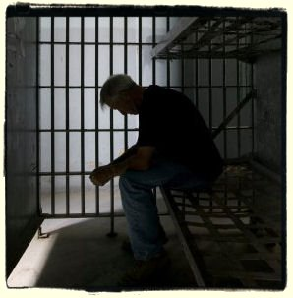

The Corrections Ministry of the Archdiocese of Indianapolis is grounded in Jesus' Parable of the Last Judgment from Matthew 25:36,40: "I was in prison and you came to visit me. . .I will assure you as often as you did it for one of my least brothers, you did it for me". (New American Bible)

In the Parable of the Last Judgment we see Jesus identifying himself as the one who is hungry, thirsty, a stranger, naked, sick and a prisoner. He calls each and every Christian to the ministries of care, outreach and justice; thus, "Corrections Ministry" is an outreach of Jesus' love and compassion. This outreach isn't only to prisoners, but includes all affected by crime: victims, families of both, corrections officials, officers, etc.

Corrections Ministry is also grounded in Catholic Social Doctrine.

Social Justice is based on the concepts of human rights and equality and can be defined as "the way in which human rights are manifested in the everyday lives of people at every level of society".

Catholic Social Teaching is a rich treasure of wisdom about building a just society and living lives of holiness amidst the challenges of modern society. At the heart of Catholic Social Teaching are seven themes. (USCCB)

SEVEN THEMES OF CATHOLIC SOCIAL TEACHING

* Life and Dignity of the Human Person
* Call to Family, Community & Participation
* Rights and Responsibilities
* Option for the Poor and Vulnerable
* The Dignity of Work & the Rights of Workers
* Solidarity
* Care for God's Creation

CORPORAL WORKS OF MERCY
The Corporal Works of Mercy (Isaiah 58 & Matthew 26) are found in the teachings of Jesus and give us a model for how we should treat all others, as if they were Christ in disguise. (USCCB)

Feed the Hungry
Give Drink to the Thirsty
Shelter the Homeless
Visit the Sick
Visit the Prisoners
Bury the Dead
Give Alms to the Poor

THE CALL TO PARISHES

PARISH AWARENESS OF CATHOLIC SOCIAL TEACHING
(USCCB Publication No. 5-315)

We believe that every person is precious, that people are more important than things, and that the measure of every institution is whether it threatens or enhances the life and dignity of the human person.

We believe that people have a right and a duty to participate in society, seeking together the common good and well-being of all, especially the poor and vulnerable.

We believe that human dignity can be protected, and a healthy community can be achieved only if human rights are protected and responsibilities are met.

Therefore, every person has a fundamental right to life and a right to those things required for human decency.

Not everyone is called to Corrections Ministry. However, as Christians we are all called to remember our incarcerated brothers and sisters, and all affected by crime, to our merciful and compassionate God.
WHAT CAN DEANERIES, PARISHES AND INDIVIDUALS DO?

Establish a Parish Social Ministry (PSM) committee, if you don't already have one. Some parishes already have a committee based on Catholic Social Teaching that may have a different name, such as Social Justice Committee or Creation Care Committee. The archdiocesan website has everything you need to help you establish such a committee. Go to:

www.archindy.org/psm
Browse our Site
Offices and Agencies
Parish Social Ministry (PSM)

A PSM is a natural fit for a Corrections Ministry Committee if your parish feels called to extend ministry to the incarcerated either before, during, or after incarceration. Some parishes are perfect for some form of corrections ministry due to their location close to correctional institutions.
of inmates, or victims of crime, etc. The needs are many.

Establish a Corrections Ministry Committee to assist with worship, visiting, Catholic studies, scripture study, re-entry, social issues that pertain to incarceration, writing an inmate, mentoring, working with families Interested individuals may find help in connecting with an already established corrections ministry in their local area. Look at our new website at:

www.archindy.org/corrections
Offices and Agencies
Pastoral Ministries
Corrections Ministry

Whatever you or your parish chooses to do, there is one thing that is always appropriate . . .PRAY. . .for the incarcerated, victims of crime, corrections officers, families of inmates and victims, etc.

PRAY ALWAYS!

Below are phone numbers to make your search easier if interested in this vital and needed ministry:

Parish Social Ministry (PSM)
317-236-1404

Secretariat for Pastoral Ministries
317-236-1531

Corrections Ministry Coordinator
317-592-4012

10/2018
SOCIAL JUSTICE
&
CORRECTIONS MINISTRY
of the
ARCHDIOCESE OF INDIANAPOLIS
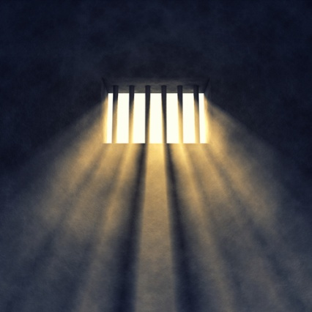

Vision
The Archdiocese of Indianapolis is a Christ-centered Catholic community that upholds the dignity of every human person touched by crime in order to practice mercy and foster hope and peace.

Mission
The mission of prison ministry in the Archdiocese of Indianapolis is to create an environment of trust through a lens of Catholic social teaching by witnessing the Gospel to the incarcerated, those formerly incarcerated, and their victims and families, through healing and mentoring processes. The Archdiocese is committed to actively engaging parishes and parishioners in educating about, and advocating for, policies that help reduce violence, and provide for the pastoral needs of all affected by crime.

