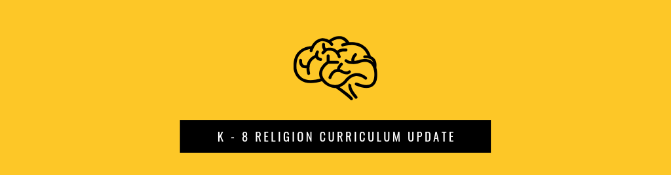

Did you know...?
- Our Archdiocesan Religion Curriculum is based on the Catechism of the Catholic Church. When you teach the concepts in our Religion Curriculum, you are teaching the Catechism at an age-appropriate level
- You don't have to teach a textbook from cover to cover. A textbook is a tool to help you teach the Curriculum concepts. The curriculum is what you teach, the book is how you teach, and Jesus Christ is whom you preach!
- The ACRE assessment is how we measure if what you're teaching is sticking so you can plan and really use your time to reach students where they need help most

The Changes...
- Curriculum was -- and will still be -- available in the "4 Pilars of the Catechism" format. This is the easiest way to see that what you're teaching matches the four sections of the Catechism of the Catholic Church: Creed, Sacraments, Christian Life, and Prayer.
- Curriculum is now availalbe in the "6 Tasks of Catechesis" format, also known as the "6 ACRE Domains" format. The content is -- still -- all the same stuff that reflects the Catechism. But it's organized in a way that also reflects the National Directory for Catechesis' 6 Tasks of Catechesis... and reflects the 6 sections or domains of the ACRE assessment.

Why the change?
- So what you teach, and how you measure, work better together. Curriculum and ACRE now have the same 6-section format.

Where can I find it?
The Religion Curriculum is available online in all formats at: http://www.archindy.org/catechesis/curriculum.html

Questions?
Contact Gabriela Ross at gross@archindy.org or (317) 236-1437.

